Joe Giannantonio
Noreen Garvey
Westchester
Hills School 29

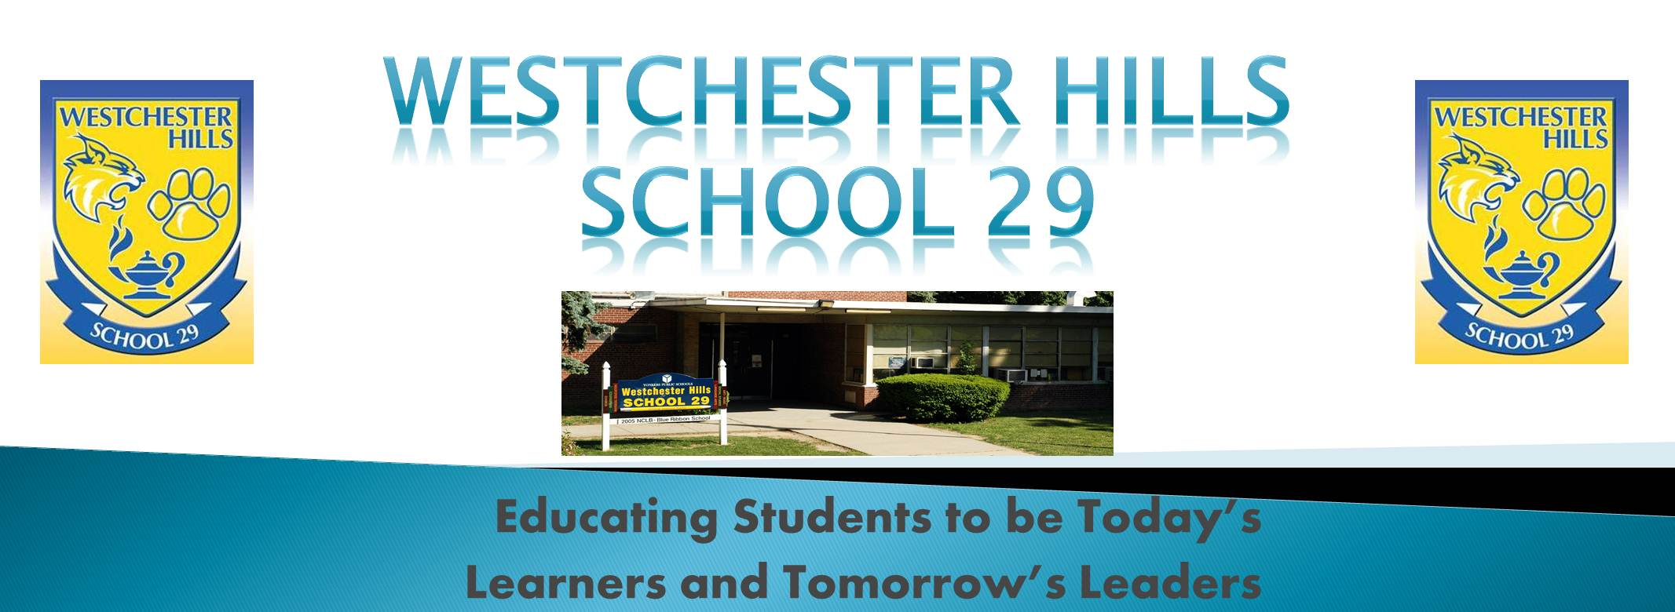

Welcome Letter
Dear Parents,

Welcome back to another school year at Westchester Hills PS 29. We are very pleased to be serving as your child's teachers. At the end of this year we will have our largest group of students (13) moving on to high school. We will endeavor to make this a memorable year for them and prepare them for the next phase of their education. We are certain we will have a smooth transition from their summer programs and activities and look forward to an exciting and productive school year.
A primary goal of our classes will be to improve each student’s ability to function independently in the home, school, society and workplace. We will also focus on supporting and easing the transition to their high school placement. More information on these last two items will be provided as we proceed. We will be working on a variety of functional and vocational skills such as identifying and utilizing tools, woodworking, completing forms, utilizing community resources such as bus and train schedules, newspapers, catalogs, maps, etc. as well as general resources such as a dictionary, thesaurus and online search engines. We will utilize these activities to foster and/or reinforce academic skills. We will once again be working on several ecology/ environmental projects this year and taking care of various class and school pets. Our over-riding cross curricular theme this year will be the universe and space exploration. We hope to organize several interactive projects as well as trips related to this theme. Additionally, we plan to continue our woodworking projects, scrapbooking unit and rocketry unit. More information on these also will follow.
We will be sending home a copy of their daily schedule which will outline that day’s lessons/activities, its completion and/or progress as well as any comments regarding their day, questions, etc. We have attached a sample of the schedule to this letter. Once we begin implementation of our daily schedule please review and sign their schedule each evening and return it to school the following day. Completed schedules should begin arriving home by Monday the 16^{h}. Also, please feel free to respond to any comments or ask any questions either on the back of the schedule or in their communication book. You can also contact us via email at jgiannantonio@yonkerspublicschools.org and ngarvey@yonkerspublicschools.org . We will read these the morning of each school day and respond as soon as possible.
As we do each and every year, we will take the first several weeks to assess/re-assess each student’s strengths and needs and review some of the things they learned during the latter part of the last school year. We will then jump right in to our program both in school and with weekly homework assignments. Students’ homework assignments will serve as both a review and a reinforcement of classroom instruction and should begin by the week of October 7th and end the week of May 18th. Each child will be assigned a vocabulary, spelling and math group. Group vocabulary lists will be given out each Monday. In addition, reading to and/or with your child for at least 20 - 30 minutes each night will prepare him/her for further academic development (see attached Daily Reading Log). Students may begin completing daily reading log entries immediately.
Thank you as always for your support and dedication, both to your child and to our school community! We are looking forward to another productive and exciting school year.

Sincerely,

Mr. Giannantonio (Mr. G) and Ms. Garvey

Date: | September 2019
Classes: | SC-10 Room 116  SC-11 Room 110

Sincerely,
________________________
(Teacher’s Name)

